Web Application Project: To-do list

Features: Add items on to-do list. Check box indicating completed or not.
Basic Components:
- check box to indicate task completion. Check must save
- ability to add new tasks
- ability to remove old tasks
Optional Advanced Features
- user specific (login or IP?)
- keep list of completed tasks in different area
- datestamping at completion

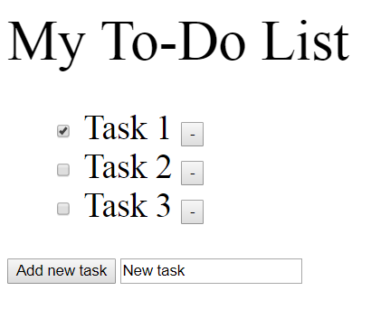

Application frameworks like django (for python) are often used.
Need HTTP server – apache tomcat
Database – SQL or XML
Client side programs: html forms and javascript
server-side: java servlet/JSP
apache tomcat is used for hosting java web apps

Justification of servlets/jsp vs alternatives Django (python) or PHP or Ruby on Rails
- relevant to company
- I am unfamiliar
- faster than python and ROR, more widely used
- statically typed – less type mismatch errors
- PHP generally requires a framework and can be less flexible

https://www.ntu.edu.sg/home/ehchua/programming/howto/Tomcat_HowTo.html
configuring tomcat – leaving port as 8080
did not enable automatic reload
-added PATH environmental variable for Java
compiled code through terminal by setting directory to apache tomcat bin then running javac with a changepath argument to select servlet-api.jar
index.html: default html page
web.xml: defines the servlet names and urls
servlet mapping: defines how the url should be for a servlet

Loading the webpage should load tasks from xml
- also load checkboxes based on completion status
Pressing buttons should manipulate xml
xml should look something like this:
<TaskList>
<Task>
<Name>Take out trash</Name>
<Complete>True</Complete>
</Task>
<Task>
<Name>Wash laundry</Name>
<Complete>False</Complete>
</Task>
</TaskList>

to manipulate xml, html form fields are often used
form fields allow input of values into fields
servlet can parse these values
- get values using request.getParameter(valuefromform)
must define get or put as method and an action (the servlet)

guess on structure:
html based on xml data
entering new task is html form – parsed by writeToXML
upon pressing button add task to XML with name=name and complete = false
update html with updated xml

each checkbox is its own html form – parsed by writeToXML
if checkbox value is echoed, update XML value based on checkbox name
it may be easier to create a separate form just for marking completion
no need to update html?

Each minus box has its own html form – parsed by writeToXML
if minus box is pressed, remove task based on minus box name
update html with updated html

jsp for dynamic webpages
“java inside html”
can use jsp to show xml using document object model
use <%= to display a variable as html
<%@ page import= “ “ %>

DOM – xml parser
requires a lot of imports..
can make a list of nodes based on tag name
nodes are elements?
Get list of elements, set root, use root to get subelements
getchildnodes will give you elements as well as text nodes. If your node has children <name>john</name> then item(0) is name and item(1) is john
.getNodeName() for tag

Displaying XML works fine, add buttons that link to servlet classes later
Added buttons using forms. Forms direct to servlet URL to activate servlet. Servlet will edit xml and load jsp
getAttributes().getNamedItem("id").getNodeValue() to get ID of node

3 servlets: addTask, removeTask, markTask
addTask
- sends task name to servlet. Servlet will add nodes to xml and refresh jsp
removeTask
- sends task ID xml attribute to servlet. Servlet will remove nodes based on ID and refresh jsp
markTask
- sends task ID xml attribute to servlet. Servlet will change Complete xml tag to complete if currently not complete or to not complete if currently complete
response.setHeader("Refresh", "0; URL=http://localhost:9999/to-do_list2/to_do_list_buttons.jsp");

read database.xml, edit accordingly and save to database.xml then refresh page. No need to send response. Use eclipse to test editing – using DOM

Java comparing strings use string1.equal(string2) – otherwise compares objects

Two options:
separate servlets for each method
pass in variable with servlet to determine method

markTask is complete – using hidden form field parameter passing

removeTask and addTask

replace identifier = 0 with request.getParameter(“name”) in addTask
go through nodes to find last identifier

Improvement:
improve css/Change button appearance/layout
Tidy up this document
add dynamic refresh in case URI changes
combine servlets into one and pass parameter

Potential Useful Features
- change priority
- Datestamping completion
- If no xml data, add message telling user to add tasks
- Host application online?

Testing:
- try to break input box

